3.1. End-user demand

3.1.1 Model countries
Originally LIBEMOD included only the western-European countries; Austria, Belgium incl. Luxembourg, Denmark, Finland, France, Germany, Greece, Ireland, Italy, Netherlands, Norway, Portugal, Spain, Sweden, Switzerland and the United Kingdom.
In this version of LIBEMOD there are 30 model countries; EU 27 (Austria, Belgium, Bulgaria, Cyprus, Czech Republic, Denmark, Estonia, Finland, France, Germany, Great Britain, Greece, Hungary, Ireland, Italy, Latvia, Lithuania, Luxembourg, Malta, the Netherlands, Poland, Portugal, Romania, Slovak Republic, Slovenia, Spain, Sweden) and Iceland, Norway and Switzerland. In addition there is supply and demand for some goods in Algeria, Belarus, Russia, Ukraine, YU (consists of the countries of former Yugoslavia) and ROW (an aggregate of the remaining countries of the world). In an extension of the model we have included Russia as a model country. For details see chapter 3.7.
Figure 1 Map of model countries and exogenous countries
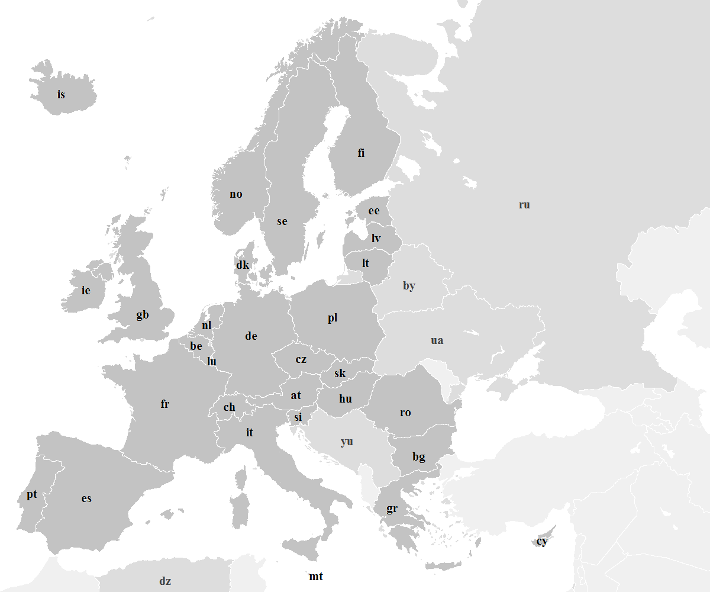 All model countries are marked dark grey and exogenous countries in lighter grey. All other countries are included in row (rest of the world).

3.1.2 Period length
Fossil fuels (coal, oil, natural gas) and biomass are traded in annual markets, whereas electricity is traded in two seasonal markets (summer and winter). Each season consists of two periods (day and night). The winter season is from 1st October to 31st March, whereas the summer season is from 1st April to 30th September. Day is defined as from 08.00 am to 08.00 pm, and night from 08.00 pm to 08.00 am.

3.1.3 Quantities
Demand in each model country is divided into four end-user groups or sectors, denoted “household”, “industry”, “services” and “transport”. The base year demand for all fuels is taken from IEA Extended World Energy Balances and is measured in million tons of oil equivalents (Mtoe). The energy demand is broken down into a detailed list of end users. For the household, service and transport sectors the IEA categories are used directly. This implies that the service sector includes both commercial and public services as this is not separated in the data set. Agriculture, forestry, fishing and other non-specified consumption has been included in the industry sector, along with non-energy use from the same categories.
The demand for fossil fuels in electricity generation is an aggregate of the demand from electricity producing plants, combined heat and power plants (CHP) and heat plants. A total of seven categories from the IEA statistics are included (Main activity producer electricity plants, Autoproducer electricity plants, Main activity producer CHP plants, Autoproducer CHP plants, Main activity producer heat plants, Autoproducer heat plants and Chemical heat for electricity production).
Base year demand for electricity is taken from the same source, and is measured in terawatt-hours (TWh). The same classifications for the sectors as outlined above have been used. Heat demand is added to the electricity demand in “household”, “industry” and “services” after converting the heat usage to electricity equivalents (see chapter 3.2 for more details).
To calibrate the demand for electricity in each period, actual country data from ENTSO-E on hourly load has been used. ENTSO-E has data for 2009 for most of Europe, except the Nordic countries, Latvia, Lithuania, Cyprus and Malta. For the Nordic countries, Latvia and Lithuania 2010 data has been used as 2009 data is not available. ENTSO-E does not have any data for Cyprus and Malta so the demand profile of Greece has been used.
To differentiate the demand patterns between the different end-user sectors a British source was used (Sustainability First 2012). The publication has demand profiles illustrating variations in electricity use by time-of-day, weekday and weekend for each month for households, commercial and industry. Commercial consists of demand from offices, communication and transport, hotel/catering, other, retail, sport and leisure and warehouses, public administration (education, government and health) and agriculture. This source gives an indication of how the demand varies between sectors and has allowed us to make some assumptions on the demand profiles. These demand profiles are used for all model countries.

3.1.4 Prices and Taxes
Base year prices and taxes are mainly taken from IEA Energy Prices and Taxes (2011a and 2011b). The database provides a set of prices and taxes in national currency per energy unit, and prices in national currency per toe. All prices are converted to €/toe, apart from the electricity price that is expressed in €/MWh. All exchange rates used are from the IEA statistics (Energy Prices and Taxes) and all prices are given in 2009 prices. Heat is converted to electricity equivalents.
For many countries there are some missing values for 2009 in the statistics, especially among the non-OECD countries. As far as possible this has been solved by using other data sources, and where this was not possible by making own assumptions. Generally, if a country has a set of prices there is also information about excise taxes and VAT. In cases where the IEA only has prices for some of the sectors in a country, the available price has generally been used for the other sectors as well, i.e. if a country has a price of natural gas to industry, but not to electricity producers, the industry price has been used for both sectors. If an import price for the base year is available this has been used, along with an estimate for distribution costs, to create the price before tax. If none of this information has been available an assessment of prices in previous or following years in the IEA statistics has been made to give an indication of the price level. In some cases it has been necessary to look to the prices in neighbouring countries to complete the dataset. Where no information has been available about tax levels, it is generally assumed that only the household sector is applicable to VAT and excise taxes have been set to zero.
For industry the price of oil is a weighted average of the prices of light and heavy fuel oil, whilst for households and services the price of light fuel oil has been used. For the transport sector the weighted average of the prices of gasoline and diesel (“Automative Diesel for Commercial Use” and “Premium Unleaded (95 RON) Gasoline”) has been used, using the quantities from IEA Extended World Energy Balances as weights. There are generally few end-user prices for steam coal and coking coal in the database, and very few countries have coal prices for all end-user groups. To get a full set of coal prices additional sources were used and own assumptions made. IEA’s Energy Prices and Taxes also has import prices for steam coal and coking coal for some of the model countries, which was used as the price of coal delivered to the country’s consumption node. Distribution costs, excise taxes and VAT were then added to find the end-user price. The IEA does not provide any prices for lignite so the price of lignite is set to 70 percent of the price of steam coal in each country.
Energy Prices and Taxes does not provide prices for biofuels or biomass. The biofuel product in the model is a weighted average of bioethanol and biodiesel for each country. A set of end-user prices for biofuels in the transport sector was created by using the price of E85 (bioethanol) and the price level of unleaded 95RON (IEA 2011) for each model country. It is generally assumed that there are no excise taxes. Biomass encompasses a wide variety of different products which makes it problematic to set the end-user price. For households the price of wood pellets for each model country from the Pellets@tlas projet has been used. For the industry and the electricity producing sectors the picture is even more complex as there will be considerable differences in the type of biomass used by industry customers and power plants. In many cases local residues or industrial waste products will have a low cost (IRENA 2012). Therefore the price of biomass is based on an assessment of each country’s supply curve for biomass, transport and distribution costs.
The Energy Prices and Taxes publication does not have any price information for Iceland. Several sources have been used (www.statice.is, Lindhjem et al (2009) and www.bridgewest.eu) to make a full set of prices for Iceland.
There is also a set of producer prices for all energy sources in the base year. This can be seen as the price in each country’s production node. For gas producing countries this price has been based on BP (2012). However, for the large gas producing countries data from Rystad Energy has been used. IEA Energy Prices and Taxes provides import prices, or beach prices, for natural gas and liquefied natural gas (LNG) for a selection of OECD countries. In the model the beach price is a weighted average of the natural gas price and the LNG price, using quantities from the IEA Extended Energy Balances. All data is for the base year 2009. For the Baltic States the average gas sales price from Gazprom to CIS and the Baltic States for 2009 has been used. Gazprom also has a price to countries “beyond FSU”, which has been used for some of the eastern European countries when Energy Prices and Taxes does not have import prices.
For coking coal, steam coal, oil, natural gas and LNG the price for “EU member states” from the IEA Energy Prices and Taxes (2010/01) in 2009 has been used. For oil the price of “Brent” from the same publication has been used, whereas OECD FAO Agricultural Outlook 2011-2020 has been used for world prices for bioethanol and biodiesel. For biomass the producer price in each country is based on Biomass Futures (2012).

3.1.5 Elasticities

3.1.5.1 Direct price elasticities
The direct price elasticities are based on Dahl (2006) “Survey of econometric energy demand elasticities – progress report” which looked at 190 studies on elasticities that were published between 1991 and 2006. Based on these studies Dahl finds mean values for coal, oil and electricity. These are used to adjust the country specific elasticities used in LIBEMOD 2000 (Aune et al. 2008) for the original model countries, so that the weighted elasticities for these countries are equal to Dahl’s mean values. Quantities from the IEA statistics were then used to weigh the original elasticities. However, no elasticities were allowed to deviate more than 1/3 from Dahl’s mean value. For natural gas the household elasticities from LIBEMOD 2000 are used instead of the mean value in Dahl, as both Dahl’s estimates and LIBEMOD 2000’s industry elasticities were considered too high compared to those of other energy goods. For all new model countries (that LIBEMOD 2000 didn’t cover) Dahl’s mean values have been used (apart from for natural gas, where the household average from LIBEMOD 2000 was used). Dahl’s mean values are -0.21 in the short-run and -0.6 in the long-run for coal (household and industry), -0.14 in the short-run and -0.9 in the long-run for fuel oil (household and industry), and -0.14 and -0.56 for industrial electricity demand and -0.23 and -0.43 for household demand. For biomass the same elasticities as for oil are used for all sectors.
For oil in the transport sector, Dahl (2012) was used. This study is based on Dahl Energy Demand Database for Gasoline and Dahl Energy Demand Database for Diesel, which consists of a large selection of elasticities from various studies. The paper provides elasticities for gasoline and diesel for all the model countries. An average of the elasticities of the two fuels was used for the long-run elasticity of each country. For gasoline Dahl has a separate column of elasticities where the effects of fuel policies in the specific country have been adjusted for. For gasoline this was used. To create short-run elasticities for each country, the difference between the long-run and short-run elasticities from LIBEMOD 2000 (Aune et al. 2008) was used. The elasticities for oil in the transport sector are country specific and range between -0.06 and -0.18 in the short run and -0.18 and -0.49 in the long-run. These elasticities are also used for biofuels in the transport sector.

3.1.5.2 Cross-price elasticities
Estimates of cross-price elasticities vary significantly in the literature, and there are few comprehensive studies available. As a result of not detecting any particular pattern, equal elasticities across fuels and countries have been used. However, cross-price elasticities are assumed to be higher for industry than for households, based on the assumption that firms are more flexible in their fuel choices than households. For households 0.0125 was chosen as the short-run elasticity, and 0.05 as the long-run elasticity. For industry the values are set to 0.025 and 0.1. The same elasticities were used for the service sector as for households.
Note that the elasticities are not implemented directly in the model, but used in the calibration process of the CES demand parameters (see chapter 1.8).

3.1.5.3 Income elasticities
The income elasticities are calibrated using average projected annual GDP growth rates from 2009 to 2035, average projected annual growth rates in energy consumption (for each sector and energy type) along with corresponding projected energy prices, and the price elasticities used in the model (see above). The income elasticities can then be calibrated as the non-price changes in consumption relative to the changes in GDP. World Energy Outlook 2011 (IEA) has been used as the source for projected growth rates of GDP and energy consumption as well as for price projections. All assumptions are taken from the Current Policies Scenario (CPS).
For coal the calibrated income elasticity comes out at -0.14 for the household and service sector (this could be due to structural changes and/or improvements in efficiency). A negative elasticity is infeasible in the CES setup, and therefore the elasticity is set to a small positive number (0.2). All the other calibrated income elasticities are positive. Due to lack of sources for biomass, we have used the same elasticities as for oil.

3.1.6 GDP Growth rates
Historic GDP growth rates and projections until 2017 are taken from the IMF (International Monetary Fund World Economic Outlook Database). The database provides data for all the model countries and the exogenous countries Algeria, Belarus, Russia and Ukraine. For YU (the countries of former Yugoslavia) the average of Serbia and Croatia has been used, and for ROW (rest of the world) the growth in GDP for the rest of the world. Historic GDP growth rates from 2009 to 2012 and projections from 2012 to 2017 are used. For 2018 to 2030 World Bank projections for GDP growth have been used for all countries. From 2030 to 2050 World Bank projections of population growth are used, along with an assumption of a gradual reduction in GDP per capita growth rates towards 1% p.a. from 2030 to 2050.
Average annual GDP growth from 2009 to 2035 varies from 0.9 to 4.2 % among the model countries. The countries with the highest growth rates are the Baltic States (Lithuania 4.2 %, Latvia 4.0 % and Estonia 3.5 %) and Eastern European countries like the Slovak Republic (3.8 %), Czech Republic (3.6 %), Slovenia (3.2 %) and Hungary (3.2 %). The lowest rates are found in Southern Europe in Greece (0.6 %), Italy (0.9 %), Portugal (1.0 %) and Spain (1.0 %). Growth rates among many countries in Northern Europe are also at the lower end of the scale; Denmark (1.1 %), the Netherlands (1.2 %), Germany (1.3 %) and Belgium (1.3 %).

3.1.7 CES Demand parameters
The final demand sectors are modelled using a nested Constant Elasticity of Substitution (CES) utility function, thereby combining consistency in behavior with relative flexibility in calibrating the demand elasticities of the main energy commodities. In the nested CES formulation, a nest is a CES function of one, two or several primary or market commodities. This effectively defines a composite or aggregate commodity that may itself be an argument of a higher-level CES function. In higher-level CES nests, the arguments may be both lower-level nests and primary commodities, collectively called goods. In the top-level nest, a general “money” commodity enters complementarily to the total energy aggregate. The price of this money good is set at one, and the quantity is calculated to make the sum of the values of the energy aggregate and the money good equal to the value of the total consumption.
The prices and quantities in the CES demand tree are taken from the above mentioned sources (see chapter 1.3 and 1.5). We have annual energy goods (gas, oil, steam coal, coking coal, lignite, biomass and biofuels) as well as the four period electricity goods. As each main or aggregate good (gas, oil, coal, bioenergy and the annual electricity aggregate) enters in a nest complementary to an “energy-using good”, the quantities and prices of these have to be specified. Lacking good sources, the prices of the complementary goods are all set to one (thus, indirectly defining the unit of measurement), and the quantities are all assumed to be equal to the value of the energy good in question. For the total value of consumption, including energy and non-energy goods, the values are taken from statistics on final consumption expenditure from Eurostat. The gross value of production by sector is taken from Eurostat for all countries, where we have used the “National accounts by 21 branches” dataset. The value of production for the industry sector consists of the Eurostat-categories (i) agriculture, forestry and fishing, (ii) mining and quarrying, (iii) manufacturing and (iv) construction. The value for the transport sector is equivalent to transportation and storage in the Eurostat dataset, whereas the remaining categories (except electricity, gas, steam and air conditioning supply) make up the service sector. For the household sector we have used data on final consumption expenditure from Eurostat.
For Bulgaria, Great Britain, Ireland and Malta there were missing values for some of the sectors in 2009. For the countries where data is available from previous years, the same growth rate has been assumed as for other sectors in the country (i.e. assume the same growth in the industry sector as in the household sector), whereas for countries without any information assumptions have been made based on other countries with similar demand profiles.
The share and substitution parameters in the CES tree are calibrated to minimize the deviation from the target own-price and cross-price demand elasticities; see tables. In addition to the elasticities for annual energy goods discussed extensively above, the target cross-price elasticities in each season between electricity in the two periods of the 24-hour cycle are set at 0.2, and the target cross-price elasticities between summer and winter are set at zero.
With respect to coal only sources for aggregated elasticities have been identified. However, assuming that these are much easier to substitute in final demand seems reasonable and the target cross price elasticities have been set at 1.5 between coking coal, lignite and steam coal.
In the short-run model, the “endowment” parameters in the CES tree are set to zero. In the long-run model, the “endowment” parameter for each good is calculated so as to set the income elasticity at the target value specified above, at the same time recalibrating the share and substitution parameters with the same procedure as in the short –run model. If the model is run with a medium-term perspective of e.g. 10 or 15 years, the target elasticities are set midway between the short-run and the original long-run target elasticities.

3.1.8 Demand for energy in non-model countries
The exogenous countries (Algeria, Belarus, Russia, Ukraine, YU and ROW) have demand for coal, oil and gas to complete the global fossil fuel balances. For steam coal and coking coal the short- and long-run demand elasticities for exogenous countries are set to half of Dahl’s European average. This reflects that the coal markets are less integrated than the oil markets. For oil the elasticities are set to 2/3 of the European average. For gas it is set to half of the European average, except for demand from the rest of the world (ROW) which is modelled separately (see chapter 2.1).

3.2. Supply
The inverse supply function P = Ae^{B(t)S}+D(t)S is used for coal, oil, gas, biofuels and biomass, where P is the price, S is supply and A, B(t) and D(t) are parameters. Note that B(t) and D(t) may be time dependent. In general the parameters differ across countries, but A is the same for all countries (the only exception is biomass where A is country specific). The magnitude of B(t) and D(t) generally reflects how quickly marginal costs rise as output increase.

3.2.1 Supply of fuels
The base year supply of oil is taken from the IEA Extended Energy Balances database. This database has data for all the model countries. The production of crude oil (the sum of crude oil, natural gas liquids, refinery feedstock, additives and other hydrocarbons, as classified by the IEA), minus the “own use” (which is the “oil and gas extraction” under “energy industry own use”) is used. The inverse supply functions for oil are calibrated so that the supply elasticities in the base year are equal to 1 in the long run, whereas in the short run these are 0.25. This applies to both model countries and exogenous countries. The parameters in the inverse supply functions are adjusted over time in accordance with projections from World Energy Outlook 2011 (IEA 2011).
The coal supply is modelled separately for the three types of coal; steam coal, coking coal and lignite. The base year supply of coal for all model countries is taken from the IEA Extended Energy Balances database. Steam coal is the sum of anthracite, other bituminous coal and sub-bituminous coal, whereas lignite is the sum of lignite and peat. The IEA implicitly provide conversion factors from tons to toe in their dataset of prices (national currency/tonne and national currency/toe) in the Energy Prices and Taxes online database. These conversion factors reflect quality differences in the coal. For the countries without a price for steam coal and/or coking coal, the average conversion factors (based on the IEA data for other European countries) have been used.
The inverse supply functions for coal are calibrated in the same way as for oil, except that the targeted supply elasticity (for all coal types) is 2 in the long run and 0.5 in the short run. This applies to both model countries and exogenous countries. The assumed annual growth in coal production is based on projections from World Energy Outlook 2011 (IEA 2011). For lignite it is assumed that production declines with 4 % a year for all model countries. This is based on the “New Policies Scenario” in World Energy Outlook 2012 (IEA 2012) for coal production in the EU towards 2035 (table 5.6, p. 168). From 1990 to 2010 there has been an annual decline of 1.4 % for lignite production. Out of the three coal types (steam coal, coking coal and lignite) the IEA expects lignite production to fall the most towards 2035 in all their three scenarios.
The base year supply data for natural gas is taken from the IEA Extended Energy Balances database. In the model there is a differentiation made between countries that are large gas suppliers to Europe (Russia, Norway, Netherlands, Algeria and the UK), and the remaining countries.
For the five large gas suppliers the future supply is split into “existing fields”, which consists of fields that were in operation in the base year, and “new fields”. To distinguish between existing and new fields, unofficial data from Rystad Energy has been used. For the “existing fields”, an inverse supply function is calibrated setting D(t) = 0. The parameter B(t) is changed over time reflecting projected depreciation rates according to the data from Rystad Energy. For the new fields, inverse supply functions are calibrated (these also vary over time), again based on the data from Rystad Energy.
For the remaining model countries the inverse supply functions are calibrated based on the market equilibrium in 2009, where a common gas price (P) of 280 $/toe (7 $/Mbtu) is assumed. This price is just below the average CIF price in the EU in 2009 (which was 8.5 $/Mbtu), and also lower than the price in all years between 2006 -2010, but above the prices in all years prior to 2006. The supply elasticity in the base year is set to 0.75. This is lower than for oil, reflecting that gas is more dependent on infrastructure. For Poland supply of shale gas is phased in as of 2020.
The base year supply of biofuels for the model countries is taken from the IEA Extended Energy Balances database and is an aggregate of bioethanol and biodiesel. It is assumed that annual biofuels supply has a growth rate of 2.2 %, again based on IEA (2011).
The supply of biomass is based on data from Biomass Futures (2012). This source has supply curves for EU27 (information about type of biomass, costs in €/toe and potential ktoe). This source is used to calibrate parameters for each model country (A, B(t) and D(t)). For Norway Scarlat et al. (2011) has been used, supplemented by ENOVA SF (2008) and Hobbelstad (2009), to estimate the potential. The cost data for Norway is based on data from Sweden. For Iceland and Switzerland own assumptions were made based on data from other European countries.

3.2.2 Hydropower
In the model hydropower is split into reservoir hydro, run-of-river and pumped storage plants. The main hydro capacity and production data is taken from IEA Electricity Information, supplemented by EURELECTRIC Power Statistics and Trends 2011 and NORDEL (2008) for run-of-river. NORDEL only has data up until 2008, but we assume that the 2008-data are representative for 2009.
To estimate the hydropower potential in each model country data from the World Atlas and Industry Guide (published by The International Journal on Hydropower and Dams) was used. This source provides a gross, technical and economic hydropower potential for all the model countries. The economic potential is defined as the portion of the gross theoretical potential that could be or has already been developed under local economic conditions with current technology. It is not clear whether the economic potential includes sites that would be unacceptable to develop due to social or environmental restrictions. NVE (2011) has more specific data for Norway which shows the share of the economic potential that is protected and unlikely to be developed in the future. For Norway this means that the remaining potential is reduced by more than half. It is likely that these kinds of restrictions apply also in other countries, so to ensure that the hydropower potential is not overestimated it has been reduced by half for all model countries.
Table 1 Hydropower potential
Country | Economically feasible hydro potential (TWh) | Potential already developed in 2009 | Hydro potential in LIBEMOD
at | 53.200 | 37.542 | 7.829
be | 0.400 | 0.400 | 0
bg | 14.800 | 2.900 | 5.950
ch | 5.771 | 35.229 | 2.886
cy | 23.498 | 0.002 | 11.749
cz | 3.380 | 2.032 | 0.674
de | 20.000 | 20.000 | 0
dk | 0.070 | 0.026 | 0.022
ee | 0.375 | 0.048 | 0.164
es | 37.000 | 33.859 | 1.571
fi | 16.024 | 13.300 | 1.312
fr | 98.000 | 68.952 | 14.524
gb | 9.000 | 4.077 | 2.461
gr | 15.000 | 4.345 | 5.327
hu | 4.59 | 0.223 | 2.184
ie | 0.950 | 0.723 | 0.113
is | 40.000 | 12.247 | 13.877
it | 50.000 | 48.033 | 0.984
lt | 1.295 | 0.400 | 0.448
lu | 0.137 | 0.090 | 0.024
lv | 3.900 | 3.375 | 0.262
mt | 0 | 0 | 0
nl | 0.130 | 0.089 | 0.020
no* | 37.654 | 121.872 | 18.827
pl | 7.000 | 3.879 | 1.561
pt | 19.800 | 12.648 | 3.576
ro | 40.000 | 15.700 | 12.150
se | 90.000 | 64.875 | 12.563
si | 6.000 | 4.286 | 0.857
sk | 5.000 | 4.286 | 0.359
* For Norway the main source is NVE as the economic potential equals the technical potential in the data from The International Journal on Hydropower and Dams.
Table 1 shows the economically feasible hydro potential from the World Atlas and Industry Guide, the potential already developed in 2009 (based on inflow capacity in a hydrological normal year), and the reduced potential used in the model.
The inflow capacity in a hydrological normal year is defined as the amount of precipitation that reaches the catchment area and is available for hydropower production. For Iceland, Norway, Sweden and Finland data from NORDEL (2008) had been used. For the other model countries IEA data (Electricity Information Statistics database) is used to create an inflow proxy. This is done by using the average net reservoir hydropower production per unit net reservoir hydropower generation capacity for the years 1974 – 2012, which is then multiplied by the net generation capacity of the base year 2009. The result is a country-specific estimate of inflow capacity in a hydrological normal year. We then split this between reservoir and run-of-river using several sources; EURELECTRIC Power Statistics and Trends 2011, ENTSO-E and Hydro Dam Atlas.
The reservoir capacity measures how much water (GWh) that can be stored in the reservoir; that is, the maximum amount of water that can be transferred from the end of the summer season to the beginning of the winter season, and vice versa. Below we distinguish between the nominal and feasible reservoir capacity, with the difference reflecting uncertainty margins (backup supply).
From NORDEL (2008) we have data for reservoir capacity for Norway, Sweden and Finland in 2008 and we have data on hydro generation in a hydrological normal year for the same countries (see “Inflow capacity”). With these two data sources we can construct a reservoir capacity (GWh) per unit hydropower generation (TWh) for Norway, Sweden and Finland. However, due to restrictions on the reservoir filling shares, this is then adjusted for the maximum allowed utilisation, which is taken from Nord Pool (2003). For the remaining model countries we use the average ratio of reservoir capacity to reservoir production for Norway, Sweden and Finland to create the reservoir capacity (GWh) per unit reservoir hydropower generation (TWh).
From Nord Pool (2003) we have information on the maximum, minimum and median filling shares for Norway, Sweden and Finland for 1st April and 1st October. For each of these countries we use the difference between maximum filling share on 1st October and the minimum filling share on 1st April as an approximation for the share of the reservoir that can be transferred from the end of the summer season to the beginning of the winter season. The product of a share and the corresponding nominal reservoir capacity is termed feasible reservoir capacity. Finally, for the remaining model countries, we use the weighted shares of the Nordic countries to estimate feasible reservoir capacities.

3.2.3 Solar power
In the model it is assumed that all solar power is based on photovoltaic (PV) technology and organised as centralised power plants. Based on the photovoltaic effect PV cells can convert sunlight directly into electricity. The PV cells are assembled as modules that are used for electricity generation (IEA ETSAP 2011/E11). There are several different PV technologies on the market and under development today. These are often divided into three categories; (i) first-generation PV systems based on crystalline silicon technology, (ii) second-generation thin film PV (based on several different materials) and (iii) third-generation PV which includes new technologies like concentrated PV, organic solar cells and dye sensitized solar cells. The first-generation PV systems are fully commercial, whereas the second-generation are in the stages of early market deployment (IRENA 2012). In the model we use technical data and costs of first-generation PV systems.
There are various ways to measure solar irradiance. Global horizontal irradiance (GHI) is a measure of the density of the available solar resource per surface area. However, GHI can also be measured with tilted collectors that have an optimal angle for the location or even with devices that track the sun.
To estimate the potential of the solar resource in each model country data for solar insolation around the world from the NASA Surface Meteorology and Solar Energy database has been used. This gives information about the monthly average insolation incident, measured in kWh/m²/day, based on a 22-year average. We use the data for tilted collectors, choosing the insolation data for the tilt angle that gives the highest annual average for each location. We have created a dataset with a “best” and “worst” location for solar insolation (kWh/m²/year) for each model country. These locations have been chosen based on an assessment of each model country using a map of PV potential in the EU regions and sampling from the NASA database. The data has been aggregated to our two seasons (summer/winter). The “best” and “worst” estimates are used in the calibration, and the absolute difference between locations is assumed to be constant over time.
Table 2 Solar insolation in kWh/m²/year (Average radiation incident on an equator-pointed tilted surface)
Country | Available land 2050  km2 | Insolation at best site  kWh/m2/yr Panel angle |  | Insolation at worst site  kWh/m2/yr Panel angle
AT | 161 | 1386 | 31 | 1245 | 33
BE | 75 | 1143 | 35 | 1134 | 36
BG | 257 | 1612 | 26 | 1509 | 28
CH | 79 | 1421 | 31 | 1366 | 32
CY | 6 | 2142 | 34 | 2044 | 20
CZ | 113 | 1216 | 34 | 1153 | 35
DE | 864 | 1272 | 33 | 1079 | 38
DK | 134 | 1287 | 42 | 1090 | 39
EE | 50 | 1248 | 43 | 1165 | 43
ES | 1401 | 2114 | 37 | 1601 | 28
FI | 128 | 1142 | 46 | 956 | 53
FR | 1466 | 1817 | 28 | 1175 | 35
GB | 872 | 1291 | 36 | 1109 | 37
GR | 420 | 2065 | 21 | 1516 | 26
HU | 297 | 1420 | 31 | 1254 | 33
IE | 214 | 1220 | 39 | 1089 | 37
IS | 117 | 1182 | 48 | 776 | 51
IT | 713 | 1989 | 23 | 1490 | 30
LT | 140 | 1300 | 40 | 1137 | 39
LU | 7 | 1207 | 34 | 1204 | 34
LV | 95 | 1313 | 41 | 1165 | 42
MT | 0 | 2095 | 35 | 2078 | 36
NL | 118 | 1289 | 36 | 1090 | 37
NO | 53 | 1191 | 43 | 813 | 55
PL | 829 | 1181 | 35 | 1131 | 38
PT | 185 | 1983 | 23 | 1965 | 26
RO | 701 | 1504 | 29 | 1358 | 32
SE | 169 | 1217 | 41 | 999 | 52
SI | 24 | 1568 | 30 | 1386 | 31
SK | 98 | 1285 | 33 | 1169 | 34
Source: All data from the NASA Surface meteorology and solar energy database.
Based on Hoefnagels et al. (2011) it is assumed that 0.5 % of the agricultural land will be made available for solar power plants in each model country by 2050. We also assume that the access to land for solar power production changes over time, in that it gradually becomes available towards 2050. We use the following function: b(t)=k*eksp(-a*(t-2009)), where k=2.501630631 and a= 0.022364458, so that b(2050)=1.
IEA ETSAP (2011) has data for land use (m²/kW) for PV technologies. For Crystalline Si PV cells their “typical current international range” is between 6 and 9 m²/kW. In the model 7 m²/kW has been used, which means that 7 m² is required to generate 1 kW instantly under optimal conditions. Maximum module efficiency for PV panels of 18 % is assumed, based on the assumptions in IEA ETSAP (2011) and IPCC (2011).

3.2.4 Wind power
The wind power potential in the model countries has been found using data from several sources. The load hours for wind energy in each model country is based on information from Storm Weather Centre, EEA (2009) and Hoefnagels et al. (2011a). From these sources we found the “best” location for wind power in each model country, with annual load hours ranging from 1500 to 3700. The load hours are defined as the ratio between annual electricity output of a wind turbine and its rated capacity (for details on how this is estimated see Hoefnagels et al. (2011a)).
Eerens and Visser (2008) has data for wind power potential in Europe. The report has a technical potential for each country, which is then reduced by excluding all sites with wind speeds below 4 m/s and land where biodiversity issues could prevent development (all land registered in the Natura 2000 database or as nationally designated areas (CDDA)). For each country the remaining generation potential, referred to as market potential, has been categorised into different cost classes. These are labelled “Not competitive”, “Most likely competitive” and “Competitive”. The potential within the “Not competitive” are sites with average production costs between 0.173 and 0.071 €/kWh, whereas the “Most likely competitive” and “Competitive” have an average production cost ranging from 0.048 to 0.023 €/kWh. All three categories are given for 2020 and 2030. In the model 10 % of the total potential given for the two cost classes “Most likely competitive” and “Competitive” for 2030 has been used. It is assumed that there is a cost reduction for electricity generation from onshore wind which falls from 1000 €/kW in 2005 to 576 €/kW in 2030.
Table 3 Wind hours at best site and wind power potential in model countries
Country | Best (load hours) | Potential*  2020 (TWh) | Potential* 2030 (TWh) |  | Country | Best  (load hours) | Potential*  2020 (TWh) |  | Potential* 2030 (TWh)
AT | 2000 | 0.3 | 26.7 |  | IE | 3400 |  | 131.5 | 131.5
BE | 2800 | 6.5 | 43.7 |  | IS | 3700 |  | 35.95 | 81.1
BG | 2500 | 4.8 | 27.9 |  | IT | 2000 |  | 16.9 | 58.1
CH | 1700 | 0 | 0.4 |  | LT | 3000 |  | 4.3 | 74.4
CY | 1500 | 1.2 | 3.9 |  | LU | 2000 |  | 0 | 3
CZ | 2093 | 0.1 | 51.9 |  | LV | 3000 |  | 23.9 | 85.3
DE | 2500 | 64.2 | 367.3 |  | MT | 2000 |  | 0.7 | 0.7
DK | 3200 | 75.2 | 75.2 |  | NL | 2800 |  | 31.6 | 55.3
EE | 2500 | 25.3 | 67.2 |  | NO | 3700 |  | 71.9 | 162.1
ES | 2500 | 43.3 | 170.0 |  | PL | 3000 |  | 24.6 | 364.4
FI | 3100 | 40.2 | 441.1 |  | PT | 3000 |  | 7.6 | 46.8
FR | 2500 | 130.9 | 452.4 |  | RO | 2000 |  | 5.7 | 47
GB | 3400 | 440.8 | 440.9 |  | SE | 3100 |  | 114.8 | 456
GR | 3000 | 30.5 | 44.3 |  | SI | 2000 |  | 0 | 1.9
HU | 2000 | 0 | 21.4 |  | SK | 2000 |  | 0 | 13.9
*The wind potentials in the model are 10 % of Hoefnagels et al. (2011a).
Sources: Storm Weather Centre, EEA (2009) and Hoefnagels et al. (2011a) *In the model only 10 % of the potential from Hoefnagels et al. (2011a) has been used.
We have chosen to only model the onshore wind power potential, and omitted offshore wind. We use the function f(K^{PM})=a^{W}+b^{W}K^{PM}, where f(K^{PM}) is the average number of wind hours at the best site (in a country – see table 2). We have calibrated the parameter b^{W}. b^{W} depends on the potential in a future year and time, where the access to areas that can be used for wind power increases over time captured by b(t) – see chapter 3.2.3 above. We have two alternative calibrations, one where we use the potential for 2020 and one where we use the potential for 2030.

3.3. Electricity generation
Electricity and heat generation in each model country in the base year is taken from the IEA Electricity Information database. The same source has power capacities for the electricity producing technologies. However, the IEA does not provide capacity data for non-OECD countries. This means that for the model countries that are not OECD members we have used ENTSO-E (2010), EURELECTRIC (2011) and the UN Energy Statistics Database to complete the dataset.
In LIBEMOD each power plant may use one fuel only, which implies that multi-fuelled power plants are grouped together with the single-fuelled plants. For some countries with many multi-fuelled power plants the IEA statistics only provides a total capacity for thermal plants in the base year. Because it is necessary to distinguish between coal, natural gas and oil in the model data from ENTSO-E (2010) and EURELECTRIC (2011) has been used to complement the IEA statistics for some countries.

3.3.1 Efficiencies
We differentiate between existing power plants and new plants. Efficiencies for new power plants are discussed in chapter 4.1. Efficiency differs across existing plants within each fuel category due to factors like age, variations within the technologies and plant specifications. We assume that for all existing plants in a country with the same type of technology, for example gas power, the thermal efficiency is a linear function of capacity utilization.
To determine a linear function, one requires two exogenous values. We let one point be the thermal efficiency of the most efficient plant in each country, which we define as the efficiency reported for new plants in the IEA Projected Costs of Generating Electricity, Update 2005. The publication has efficiency estimates for plants coming online in 2010 for some of the model countries for the different technologies. For countries where there are no estimates (and for pumped storage production which is not mentioned in the publication) the average efficiencies reported for 2009 (in IEA Electricity Information 2011) have been used. Because the plants that were in operation in 2009 differ in age, and hence have varying efficiencies, this estimate is adjusted by multiplying with a factor of 1.05.
A candidate for the second point of the linear function could potentially be the observed efficiency, calculated as the net electricity production to fuel use. However, it is not straightforward to use the observed average efficiencies to determine the other fixed point of the linear efficiency function. First, the unused parts of all electricity capacities have unobserved efficiency. Assuming that these are mainly vintage plants with lower efficiency, the (true) average efficiency of total capacity will be lower than the observed average efficiency. Second, the different electricity-producing technologies do not have a constant rate of capacity utilisation throughout the year. These rates are not known from primary data. The data only provide information on annual rate of capacity utilisation for each technology and the distribution of total production over the four time periods. Instead of using average efficiency directly to determine the second point, we calibrate the capacity utilisation for each technology and period by imposing the requirement that, for each country, the outcome should be consistent with cost minimization in electricity production, given our data. The problem is solved by running the electricity production block of the model. The solution of the problem provides the efficiency of the least efficient plant actually used in any period (the marginal efficiency for each technology and country), which is used as the second point in the linear efficiency function.
3.3.2 Heat efficiency
Actual thermal efficiencies for the fossil-fuel-based technologies are based on observed fuel use and production of heat and electricity in 2009 as reported by the IEA in their Electricity Information Statistics Database. The estimated heat-electricity trade-off coefficients were used to convert heat produced in 2009 to its electricity equivalent, ensuring that all electricity quantities (production and consumption) in the base year also include transformed heat.
Through using observations from the 1970s and up until today we have estimated a trade-off between heat and electricity across fuels for all model countries. There is a wide dispersion between countries and fuels. For gas, oil and coal, the results were highly significant; whereas for waste and biomass the results were only significant when these were estimated together (there are fewer observations for these).
Gas Electricity = -0,3709Heat + 0,4345Gas, (R² = 0,983)
Coal Electricity = -0,4971Heat + 0,3702Coal, (R² = 0,994)
Oil Electricity = -0,2558Heat + 0,3880Oil, (R² = 0,978)
CRW Electricity = -0,1393Heat + 0,2608CRW, (R² = 0,916)
The first coefficient is interpreted as the change in electricity produced per unit increase in heat production, and the second coefficient as the gross thermal efficiency had all production been electricity.
We use the estimates for gross electricity production, along with the ratio between net and gross electricity production for combustible fuels (found through using data from IEA Electricity Information), to calculate the net electricity production for the combustible fuels. This source also contains data on net electricity production from other types of technologies.

3.3.3 Operation and maintenance costs
In the model we differentiate between fixed and variable operation and maintenance costs (O&M). Fixed O&M costs are costs that incur irrespective of use and therefore can be viewed as long-run maintenance costs, whereas variable O&M costs are linked to the maintenance of the capacity that has been used during a year. Schröder et al. (2013) consider fixed O&M costs to include labour, regular and irregular maintenance work, property tax, insurance and network use of system charges and variable O&M to cover constant maintenance contracts (i.e. periodic inspections, repair of system components and consumables, water, lubricants and fuel additives).
The OECD-publication “Projected Costs of Generating Electricity 2010 (OECD 2010) provides estimates for total O&M costs, so other sources have been used for the split between fixed and variable costs. Tidball et al. (2010), NREL (2012) and UK Costs of Generating Electricity 2010 provide more detailed information about O&M costs. Schröder et al. (2013) provides a compilation of different studies and their assumptions for fixed and variable O&M costs for different technologies. Based on an assessment of these sources a dataset has been created.
Costs from OECD (2010) have been used for natural gas, steam coal, lignite and nuclear power plants. For steam coal we assume that of the total O&M costs 54 % are variable and 46 % are fixed, whilst for lignite the allocation is 35 % variable and 65 % fixed. For natural gas (combined cycle) we assume that variable costs make up 55 % and fixed 45 %, and for nuclear 4 % variable and 96 % fixed. For oil power Tyma (2010) provides an overview of personnel costs, fuel costs and chemical costs, which have been allocated to fixed and variable costs in keeping with the above definition. For biopower we have used IRENA (2012), and assumed that 42 % of the O&M costs are variable, and 58 % are fixed. The Danish Energy Authority (DEA 2010) has detailed O&M data for waste power.
In the overview made by Schröder et al. (2013) the majority of the studies on hydro power categorise all the O&M costs as fixed. In their own dataset they report only fixed O&M. The O&M costs for pumped storage, reservoir and run-of-river hydropower in LIBEMOD are based on this.
The O&M costs for solar power, geothermal and other renewables are based on data from the technology briefs from IEA ETSAP. The costs for wind power are based on OECD (2010) and IRENA (2013). For wind power the four studies evaluated by Tidball et al. (2010) differ considerably with respect to the allocation between fixed and variable costs. Two of the studies assume with 100 % fixed costs, and two 25 % fixed costs and 75 % variable costs. Schröder et al. (2013) compares O&M costs for onshore and offshore wind power from various sources and it varies between only fixed, and a split between the two. In their cost proposal Schröder et al. (2013) assume all O&M costs are fixed. In LIBEMOD it is assumed a 75/25 split between fixed and variable costs.
Table 4 Operation and maintenance (O&M) costs for existing power plants
 | Variable  O&M costs  €/MWh | Fixed  O&M costs  €/kW/year
Natural gas | 2.2 | 11.6
Coal | 3.6 | 18.8
Lignite | 3.7 | 22.6
Oil | 27.9 | 6.1
Nuclear | 5.8 | 35.8
Bio | 3.4 | 91.6
Geothermal | - | 101.8
Pumped storage | - | 20.0
Reservoir hydro | - | 20.0
Run-of-river | - | 58.8
Solar PV | - | 36.4
Wind | 6.7 | 52.0
Waste | 22.3 | 157.0
Sources: NREL (2012), OECD (2010), Schröder et al. (2013), Tidball et al. (2010), Tyma (2010), IRENA (2012), DEA (2010), IEA ETSAP Technology Briefs and own assumptions.
For mature technologies the same O&M costs have been used for existing plants and new plants. For bio, solar and wind power the costs for new plants are based on the same sources, but lower than for existing plants reflecting cost reductions as these technologies mature.
For the CCS technologies the O&M costs for greenfield plants are taken from ZEP (2011) and for retrofitted plants from IEA GHG (2011). However, the O&M costs for retrofitted coal plants have been adjusted somewhat as they were lower than for greenfield plans.
Table 5 Operation and maintenance (O&M) costs for new power plants
 | Variable  O&M costs  €/MWh | Fixed  O&M costs  €/kW/year
Natural gas | 2.2 | 11.6
Coal | 3.6 | 18.8
Lignite | 3.7 | 22.6
Oil | 27.9 | 6.1
Nuclear | 5.8 | 68.7
Bio | 2.8 | 80.7
Pumped storage | - | 20.0
Reservoir hydro | - | 20.0
Run-of-river | - | 58.8
Solar PV | - | 25.4
Wind | 7.4 | 19.5
CCS coal greenfield | 3.3 | 57.2
CCS coal retrofit | 7.1 | 51.4
CCS gas greenfield | 2.8 | 33.7
CCS gas retrofit | 3.9 | 46.8
Sources: NREL (2012), OECD (2010), Schröder et al. (2013), Tidball et al. (2010), Tyma (2010), IRENA (2012), DEA (2010), IEA ETSAP Technology Briefs and own assumptions.

3.3.4 Start-up costs
Historically most thermal power plant capacity has been used for base load generation, but in recent years more flexibility has been required as a result of more intermittent renewable energy entering the power grid. A detailed modelling of start-up requires distinction between different types of start-up, depending on for how long the power plant has been turned off. In the literature the usual distinction is between cold, warm and hot starts. How these start-ups are defined may vary due to plant specific conditions. Schröder et al. (2013) refer to the following definition:
Cold start: When a plant is shut down longer than 50 hours.
Warm start: When a plant has been turned off for less than 50 hours, but more than 8 hours.
Hot start: When a plant has been turned off for less than 8 hours.
Technical parameters like start-up times, ramping load gradients, minimum up- and downtime and minimum load, along with the economic parameters linked to costs and efficiencies have to be taken into account to model start-up accurately. This requires power market models with a plant specific resolution. In LIBEMOD we only model day/night and summer/winter and the model is not power plant specific. As a result our modelling of start-up costs is very simplified and the whole fleet of power plants is considered as one block. Each technology has a given amount of cold starts per season. We assume that the start-up costs consist of two components. One is linked to fuel costs due to the higher fuel use during the starting process, and the other to fatigue costs as a result of wear and tear on the power plant from stopping and starting.
The sources for start-up costs are limited, and as outlined above they are often linked to various assumptions related to start-up times and power plant characteristics. We have chosen to use data from DENA 2005, which provides costs per cold start and start-up fuel use for combined cycle gas turbine (CCGT), hard coal, lignite and nuclear power plants.
Table 6 Start-up assumptions
 | Assumed number of  start-ups per season | Start-up costs  per start (M€/GW) | Start-up fuel use  (Mtoe/GW)
Gas power | 90/180 | 0.0111 | 0.0003
Coal power | 26 | 0.0053 | 0.0005
Lignite power | 26 | 0.0033 | 0.0005
Oil power | 90 | 0.0824 | 0.0005
Bio power | 26 | 0.0097 | 0.0005
Waste power | 26 | 0.0346 | 0.0005
Nuclear | 12 | 0.0019 | 0.0014
Source: DENA (2005) and own assumptions.
Table 6 shows the start-up costs for each technology. For our two seasons we have assumed a specific number of start-ups for each technology. For gas this differs between old and new gas power due to the increased flexibility now available from new plants (Schröder et al. 2013, Siemens 2010). According to Schröder et al. (2013), the differences in specific start-up costs across technologies are small. For biomass and waste power we have therefore made assumptions based on the costs for coal power as there are no available sources. For reservoir hydro, run-of-river and pumped storage, wind power, solar power and other renewables the start-up costs are naturally set to zero.

3.3.5 Availability factors
All electricity plants require some downtime for maintenance and upgrading. This is reflected in the model through restricting total annual production to a fraction of installed capacity (for each country and technology). This restriction should only reflect technical requirements, because the model endogenously determines the economically optimal downtime. Unfortunately we have no clear data on the technically required downtime, as all cost calculations available use some notion of expected downtime for both economic and technical reasons. Schröder et al. (2013) provides a compilation of availability rates by technology from different sources.
Nuclear plants are typically operated for base load in most countries, so we have assumed that the actual usage reflects the technological requirements. Hence, for nuclear we have calibrated the availability coefficients as the ratio of actual use to capacity (in the base year). Some countries have either very low or very high actual usage in the base year. Because this could be due to maintenance schedules in 2009, we have restricted the downtime to the interval 0.90 to 0.95. For the fossil fuel technologies and biomass, the availability factor has been set to 0.95.
A related question is the need for balancing power in the case of large unforeseen changes in demand or the failure to supply, which otherwise may force a shutdown or even destroy parts of the electricity system. The size of this pure uncertainty would, in a fully stochastic model, be formulated as the willingness to pay for avoiding power outages; that is, we would derive an endogenous demand for power supply backup. In our non-stochastic model, a system operator buys a fixed share of 5 % of the available (maintained) capacity from the non-intermittent power sources as reserve capacity in each period and country. If there is excess capacity that exceeds this level, the price of reserve capacity is zero.

3.4 New electricity technologies
In the long-run model investments in new power plant capacity is possible apart from in lignite and waste power plants. Nuclear power investments can be endogenous or exogenous depending on the scenario.
For gas power, steam coal power, oil power and nuclear power it is assumed that all agents are in a position to invest in the most efficient technology (in the long-run model). The main source for efficiencies and investment costs for new power plants is “Projected Costs of Generating Electricity, Update 2010” from the OECD (2010). All estimates from this publication are for plants coming online in 2015.

3.4.1 New power plants
OECD (2010) provides a range of estimates for investment costs for different types of coal-fired plants from different countries. The model distinguishes between steam coal and lignite power plants, however it is only possible to invest in new steam coal plants. The cost data for an ultra-super critical (USC) pulverised coal plant is used. The OECD estimate is 1737 €/kW (data from the Netherlands). According to “Power Generation from Coal” (OECD/IEA 2011), the super-critical (SC) technology is currently the standard for new plants in industrialised countries. Despite emerging types of coal power plants like integrated gasification combined cycle (IGCC) and circulating flue gas desulphurisation (CFGD), in the choice between coal plant alternatives the super critical and ultra-super critical pulverised coal plants continue to dominate the new orders.
For natural gas the majority of the estimates from OECD (2010) are for combined cycle gas turbine (CCGT) plants. The estimates differ between the reporting countries. In the model the cost estimate from Belgium (957 €/kW) has been used, which is very close to the average of all the CCGT-estimates in the publication.
When investment in nuclear plants is allowed, OECD (2010) has been used as the source for investment costs and efficiencies. The publication provides cost estimates for several different types of reactors; European pressurised reactor (EPR), pressurised water reactor (PWR) and VVER, which is the Russian version of the PWR. An EPR plant at the lower end of the range; 3228 €/kW, has been used.
There are generally few cost estimates for new oil-fired power plants (Tyma 2010 and Schröder et al. 2013). After assessing the available sources an investment cost of 1411 €/kW is assumed.
The investment cost for new wind power plants was based on an assessment of various sources (IRENA 2012, IPCC, OECD 2010 Mott MacDonald 2010, NREL 2012 and NVE 2011). Offshore wind power potential is not included in the model. The cost estimates for onshore wind in OECD (2010) range from 1419 €/kW to 2742 €/kW. In the model the investment cost of a new wind power plant is 2298 €/kW. It is assumed that the investment cost falls over time at a rate of 1 % per anno towards 2050.
Numerous sources were reviewed for the cost of solar PV (IEA ETSAP 2011/E11, OECD 2010, IRENA 2012, IEA 2011, Bazilian et al. 2013, Schröder et al. 2013 and IPCC 2011). An estimate of 2520 €/kW is used, which is towards the lower end of the estimates of the sources mentioned. The reason for this is partly that some of the publications are several years old, and that the cost of solar PV installations has been dropping dramatically in recent years. Schröder et al. (2013) go even lower, using 1560 €/kW after reviewing numerous sources. They base their decision on the dynamics of the solar power market in recent years and argue that this leaves even the lower estimates in the literature outdated. However, because the base year in the model is 2009 a higher estimate seems reasonable. A cost reduction towards 2050 is also factored in through assuming that the investment cost per GW falls with 3 % per anno.
IPCC (2011) defines biomass as “Material of biological origin (plants or animal matter), excluding material embedded in geological formations and transformed to fossil fuels or peat.” This wide definition and variety of technologies that come under the term “bio power” means that landing on a cost estimate for a generic plant is problematic. The cost of biomass-based power generation depends on type of feedstock used, boiler technology, plant capacity and type of plant. The estimates from OECD (2010) vary considerably from country to country, mainly due to differences in the reported technologies. IEA ETSAP has a range for typical values for a biomass CHP plant in 2010 and an estimate for expected costs in 2020. For new plants it seems reasonable to go with the lower end of what IEA ETSAP estimates today, assuming that the cost of a new biomass power plant is 2181 €/kW.
For the hydro technologies apart from pumped storage, cost data from NVE for Norway has been used. The costs for other model countries are then based on this, but adjusted with an investment cost coefficient creating country specific costs for run-of-river and reservoir hydro plants. This coefficient is based on the load hours for each technology compared to Norway. We can then construct country specific investment cost estimates for reservoir hydro and run-of-river plants. The cost of new pumped storage is taken from IEA ETSAP (2012). They use 4320 $/kW for a typical pumped storage plant today (their range is from 3500 to 12500 $/kW). Because this is a mature technology we assume that this is representative.

Table 7 Investment costs in €2009/kW
Technology | LIBEMOD 2009 | IEA ETSAP (2010) | Schröder et al. (2013) | IEA (2010) | Mott MacDonald (2010)
Natural gas (CCGT) | 950 | 800 | 800 | 775 – 1291 | 806
Coal (PC SC) | 1737 | 1600 | 1200 | 1534 – 1988 | 2009
Oil | 1411 | - | 400 | - | -
Nuclear (EPR) | 3260 | 2181 | 6000 | 3228 – 5031 | 3270
Biomass | 2181 | 2181 | - | 1934 – 5482 | -
Solar (PV) | 2545 | 2400 | 1560 | 2405 – 3802 | -
Wind (onshore) | 2321 | - | 1300 | 1419 - 1742 | 1707
As mentioned above, efficiencies for new power plants have generally been taken from OECD (2010), which has efficiency estimates for plants coming online in 2015. Because of the assumption that the cost of a new plant (of a given technology) is the same for all model countries, the same applies for the efficiencies. For new pumped storage there is constant efficiency within each country, but these efficiencies differ across countries because of, e.g. topological differences. For each model country, the efficiency for new pumped storage is set equal to the efficiency of pumped storage in the base year. Table 8 shows the efficiencies used in the model for new power plants. For gas-fired power plants an efficiency of 60 percent is assumed, and for coal-fired power plants 46 percent. For details on the efficiencies of the CCS technologies see chapter 3.4.2.
Table 8 Efficiencies for new power plants
Technology | Efficiency
Coal | 46 %
Coal CCS greenfield | 37 %
Gas | 60 %
Gas CCS greenfield | 52 %
Sources: OECD (2010), ZEP (2011) and IEA GHG (2011)
Because the technical projected efficiencies do not take heat production into account, some of the observed average efficiencies for 2009 are higher than the estimate for the reported best available technology in 2010. This also supports defining the maximal efficiency as the observed 2009 average efficiency multiplied by a factor of 1.05.

3.4.2 New power plants with CCS
Carbon capture and storage (CCS) is a process to prevent CO₂ from being released into the atmosphere. A power plant with CCS is able to capture the CO₂ and transport it to a suitable location where it can be permanently stored. CCS is still an immature technology, and there are various different capture technologies under development. There are four different carbon capture and storage technologies in the model; retrofit CCS for existing coal power plants, retrofit CCS for existing gas power plants, greenfield CCS coal power plants and greenfield CCS gas power plants. The greenfield plants are new gas and coal power plants complete with CCS. The costs of the two retrofit options are based on the CCS technology being retrofitted to an already existing power plant. A CO₂ capture level of 90 % is assumed for all CCS technologies.
The costs of greenfield gas and greenfield coal plants are taken from ZEP (2011b). The report distinguishes between several different types of power plants with CCS. After consultation with industry experts, a combined cycle gas turbine (CCGT) plant and an integrated gasification combined cycle (IGCC) coal power plant were chosen. The investment costs for these were 1829 €/kW and 3080 €/kW respectively.
For retrofit CCS costs there were fewer sources. When an already existing power plant is being retrofitted with CCS equipment, the investment costs involved will be power plant and site specific. These costs are therefore more difficult to predict as some plants will require more work. However, for the model we assume that there is one retrofit technology for natural gas and one for coal. IEA GHG (2011) has investment costs for several different retrofit solutions for natural gas and coal power plants. After consultation with industry experts, we decided to use the costs for the “integrated retrofit” solution. For a natural gas plant the investment cost for this type of retrofit is 669 €/kW, whereas for a coal plant it is 1035 €/kW.
It is assumed that the investment costs for all four CCS technologies fall with 0.5 % per anno towards 2030 due to learning effects. The O&M costs for the CCS technologies are described in chapter 3.3.3.
Table 9 Investment costs of power plants with CCS
Type of CCS plant | Technology | Investment costs
Natural gas - greenfield | Combined Cycle Gas Turbine (CCGT) | 1846 €/kW
Coal - greenfield | Integrated gasification combined cycle (IGCC) | 3114 €/kW
Natural gas - retrofit | Integrated retrofit (CCGT) | 665 €/kW
Coal - retrofit | Integrated retrofit (PC) | 1027 €/kW
Sources: ZEP (2011) and IEA GHG (2011)
The cost of the integrated retrofit option only includes retrofitting the plant, the initial costs of the power plant are considered sunk. The costs in table 9 do not cover the cost of transportation and storage of the CO₂. ZEP (2011a) has cost data for this second stage where the CO₂ is transported from the capture site to the storage facility. According to ZEP (2011a), existing studies on transportation costs were inadequate for a review, so the costs in the report are based on input from EU-member states and in-house ZEP analysis. The two main transport options for CO₂ from a power plant are through a pipeline network or with ship. We have chosen to model pipelines. ZEP (2011a) provides two sets of cost estimates for pipelines. One is for a typical capacity of 2.5 million tonnes per annum (Mtpa), which is considered to be appropriate for CCS demonstration projects and commercial natural gas plants with CCS, and the other is for a pipeline with typical capacity of 20 Mtpa, which is thought more realistic for commercial large-scale networks. The unit transportation costs for CO₂/tonne vary with distance and whether it is an onshore or offshore pipeline. We have assumed a cost of 6 €/tCO₂ for transportation. This is based on an offshore pipeline of 500 km with a typical capacity of 20 Mtpa.
Storage costs depend on factors like field capacity, well injection rate and type of reservoir, and are thought to vary considerably between sites. ZEP (2011a) provides low, medium and high cost scenarios for storage depending on type of well (depleted oil and gas field or saline aquifer) and whether it is located onshore or offshore. In Europe there is more offshore than onshore capacity, and more capacity in saline aquifers than in depleted oil and gas fields (ZEP 2011a). This means that the majority of the potential European storage sites are of the most expensive kind. There has also been public resistance to storage onshore near where people live due to the risk of leakages. Taking this into consideration we assume a storage cost of 10 €/tCO₂, which is based on depleted offshore oil and gas fields in ZEP’s medium cost scenario.
Due to the carbon capture, CCS plants will incur an efficiency penalty compared to power plants without CCS. Whether the plant is a new greenfield unit or an old plant with retrofitted CCS will have an impact, however most of the literature assumes that there is little difference in the actual efficiency penalty between greenfield plants and plants that are retrofitted. The difference in actual efficiency can mainly be attributed to how older existing plants that are candidates for being retrofitted have a lower efficiency than a newly built plant made specifically for CCS. The reduction in efficiency for retrofits is plant specific, and the plants’ efficiency will fall and costs increase depending on to what degree it is suitable for CCS (IEA 2007). Many existing plants may not be good candidates for CO₂ capture retrofit due to being too small and/or too inefficient. Burnard and Bhattacharya (2011) assume that the higher the efficiency of the existing plant, the more favourable it will be to retrofit. Due to the limited experience with retrofit projects there is considerable uncertainty regarding how low a power plants initial efficiency can be before the plant is unsuitable for retrofit.
For coal plants there may also be a higher penalty for retrofitted plants if the damp from the turbine is not completely compatible with what the capture process requires (Gassnova). The IEA GHG study uses a 9 percentage point reduction for both greenfield and retrofitted plants. ZEP and NETL also use the same reduction across types of plants; 8 and 10 percentage points respectively.
Based on this literature and advice from industry experts, we assume that the penalty for natural gas plants (greenfield and retrofit) is an 8 percentage point reduction in efficiency, and likewise a 9 percentage point penalty for both types of coal power plants. For greenfield plants the reduction is based on the efficiency of new plants without CCS, 60 % for natural gas and 46 % for coal powered plants. Because the retrofits are installed on old power plants, we assume that the reduction is from the distribution of efficiency of what we refer to as “old plants” in each country in LIBEMOD.

3.4.3 Grid connection costs
When investment is made in a new power plant, one of the cost components involved will be to get the plant connected to the grid. This additional cost of grid connection is not included in the cost estimates mentioned above, apart for reservoir hydro and run-of-river plants. So for all other technologies it is assumed that there is an additional grid connection cost when investing in a new power plant. This cost is made up of two elements; the new transmission lines to connect the plant to the grid and reinforcement of the grid as a result of a new plant coming online. Both of these aspects are often discussed with regards to wind power plants, as the good wind power resources may be located far from the load centres and because introduction of intermittent power sources requires the grid to be more robust. Figure 4 (from Nielsen et al. 2006) shows the increase in grid connection costs for different shares of wind penetration.

Figure 4 Country specific transmission grid reinforcement/upgrading costs for different shares of wind penetration in €/MWh_{wind}
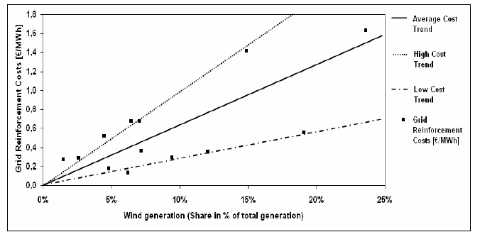
Source: Nielsen et al. 2006.
According to GreenNet (2006), the approach to cost allocation for grid reinforcement varies across Europe. In some countries the developers only pay for the connection to the grid, whereas in other they also have to cover a share of the grid integration costs. In the model we have not distinguished between countries. Issuance of EU directives on cost transparency in grid infrastructure in general is likely to encourage more countries to move towards a separation of the costs in the future (GreenNet 2006).
In the model it is assumed that all technologies have an extra cost component linked to grid connection. According to IRENA (2012), this cost makes up between 9 and 14 % of total investment costs for onshore wind. It is therefore assumed that if the average wind power capacity in the model countries increases with 10 %, then the extra cost of grid connection (including the cost of upgrading the existing network due to congestion as a result of more plants coming online) for the marginal wind power plant is 10 % of the investment costs for wind power. This is the same for all countries. We then assume that 80 % of this cost is linked to actually connecting to the grid, whereas the remaining cost is linked to upgrading the grid.
For the other technologies it is assumed that the location of the plant is more flexible (it is easier to adjust the location than for a wind power plant). This is supported by figure 5 (from EIA 2012), which shows different cost components in the levelised cost of new electric generating technologies in 2017. This gives an idea of the magnitude of this cost component for different technologies and has been used to make assumptions for the remaining technologies.
Figure 5 Estimated levelized costs of new electric generating technologies in 2017 (2010 $/MWh)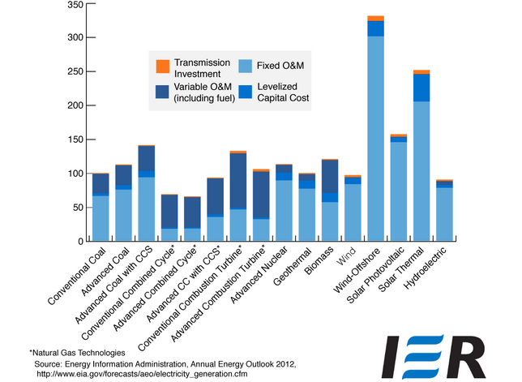

In section 2.6.5 the marginal cost of grid connection in a country for a specific technology was specified as , where p and q are parameters and is investment in a specific technology in a country. Both p (cost of upgrading the grid) and q (cost of connecting to the grid) depend on technology, but in the model we have not distinguished between countries. The table below shows the parameter values used in the model. The q-parameter of hydro is zero because these costs are already included in the investment costs.
Table 10 Parameter values for grid connection
Technology | p (M€/GW) | q (M€/GW²)
Hydro | 2.2 | 0
Wind | 2.2 | 36.1
All other | 2.2 | 12.0

3.5. International energy trade
In the model we separate between energy goods that are traded on a world market and those that are traded between pairs of model countries. Electricity and natural gas can be traded between countries through international transmission lines and cables (electricity) or pipelines (natural gas). Biomass can be traded between pairs of countries. Coal, biofuels and oil is traded on world markets and trade between the model countries is not modelled explicitly. It is assumed that each model country has a central node and that international trade takes place between these.
The international transportation cost for steam coal is found using import prices for steam coal to the model countries reported in Energy Prices and Taxes (IEA 2011) and the production costs reported by countries exporting steam coal to Europe (Medium-Term Coal Market report, IEA 2011). For coking coal the main suppliers of imports to Europe are Australia and the United States (IEA Medium-Term Coal Market report 2012). Import prices for coking coal reported by the IEA (Energy Prices and Taxes 2011) and export values for 2009 reported by Australia and the United States (EIA 2010) are used.
The domestic distribution costs for steam coal and coking coal are calculated as the difference between end-user prices before tax and the import prices. The import prices and end-user prices are from IEA Energy Prices and Taxes (2011). This publication does not have a complete set of prices for the model countries, so own assumptions have been made for the countries were prices are not reported.
For oil and biofuels the spot price for Europe in 2009 has been used (IEA 2011). The transportation and distribution costs for each country have been calculated by taking the difference between end-user prices (exclusive of taxes) and the European spot price.

3.5.1 Biomass
Biomass is traded between pairs of model countries, based on the trade patterns in the base year 2009. Trade can only take place between neighbouring countries and the consumption nodes are used in the same way as for electricity (see figure 3). IEA Extended Energy Balances has information about each country’s import and export of biomass, but this does not show trade patterns between countries. Generally there are some data limitations when it comes to biomass and it has not been possible to find a complete data set for biomass trade in Europe. However, as of 2009 Eurostat has recorded wood pellets trade in Europe. Because wood pellets currently is the main traded commodity of solid biofuels (Hoefnagels 2011), the pellets trade flows from Eurostat have been used to allocate the IEA data on import and export of biomass in the base year. This provides a dataset with trade flows between the model countries for biomass.
The cost of international transportation of biomass is based on the cost of transporting wood pellets by truck per kilometre within Europe (Hoefnagels et al. 2011) and the distances between the nodes in the model countries. Hoefnagels et al. (2011) estimate the cost to be 16 €/tonne per 200 km. The distribution costs are calculated based on the difference between the end-user prices in each sector (exclusive of taxes) and the production costs in each country node.

3.5.2 Natural gas
The natural gas producing countries have a production node and a consumption node. The gas has to be transported from a country’s production node to the consumption node before it can be traded. The only exemption is Norway where the gas can be transported directly from the production node in the North Sea to the consumption nodes of the receiving countries (in line with current pipeline structures). In figure 2 the production nodes are marked in black and the consumption nodes in grey (for details on Russian gas see chapter 3.7.10). Countries that are not connected cannot trade directly.
Figure 2 Country nodes for natural gas trade
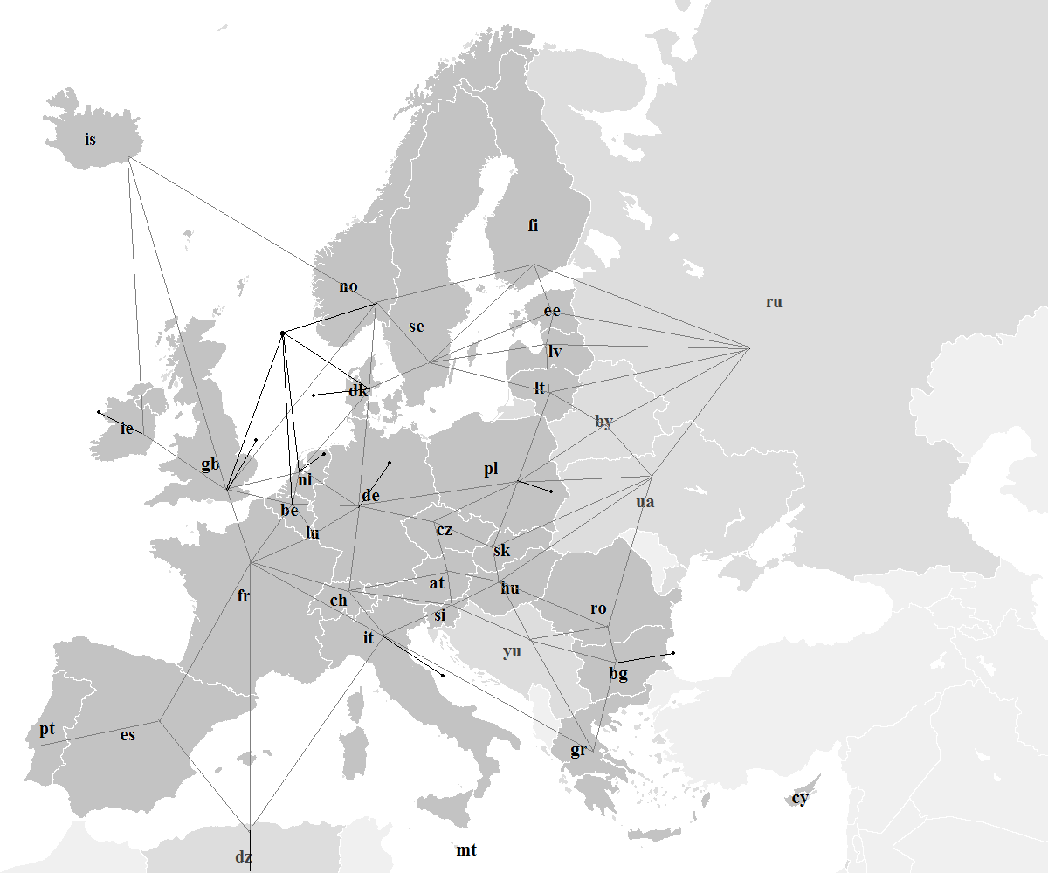All model countries are marked dark grey, whereas the exogenous countries are lighter grey. All other countries are included in row (rest of the world).
Natural gas trade flows between the model countries in the base year 2009 are based on the IEA dataset World – Natural Gas imports by origin (from the IEA Natural Gas Information online database), supplemented by country import/export figures from Extended Energy Balances as the dataset is not complete for the non-OECD countries.
Liquefied natural gas (LNG) has been modelled separately. All supply of LNG comes from a separate node (row2). Only countries with a coastline are allowed to receive LNG and the trade with row2 in the base year is based on IEA Natural Gas Information database, which has import and export data for LNG in 2009.
For the dataset on traded amounts to be consistent with the energy balance in each of the model countries some minor adjustments have been made to the trade flows in the base year. This ensures consistency with the data from IEA Extended Energy Balances in 2009.

3.5.2.1 Natural gas transmission capacity
The capacities for transmission of natural gas between the model countries in the base year are taken from ENTSOG. They provide a map of Europe and the neighbouring countries with transmission capacities at the country borders. It is assumed that all capacities are symmetrical. LNG trade is handled by assuming that all LNG is supplied from one central node (situated outside of Turkey/Greece), and can be shipped to any model country with a coast line (LNG cannot be sold to countries without a coastline). The actual traded LNG in the base year sets the initial capacity.

3.5.2.2 Costs of new natural gas pipelines
IEA World Energy Outlook (2009) has indicative costs for new pipelines to Europe in 2020. Based on this the cost of new onshore pipelines has been set to 1.08 €/toe pr. 100 km, and the cost for offshore pipelines to 2.16 €/toe pr. 100 km. IEA ETSAP (2011) has data for pipeline costs varying with capacity and steel grade. Their cost for a X70 pipeline, which is used for many of the current onshore natural gas pipelines, is in line with the onshore estimate used. In the long-run model capital costs are assumed to be 98 % of the annualised costs of new pipelines, whereas O&M costs are the 2 %.

3.5.2.3 Costs of international natural gas transport
For international transmission the loss factor is set to 2 % (conversation with industry experts) for all connections. The O&M costs of international natural gas transportation are assumed to be 2 % of the total costs of new pipelines (IEA 2009, IEA ETSAP 2011).

3.5.2.4 Costs of domestic transportation and distribution of natural gas
The national cost figures for transport and distribution of natural gas for EU 15 have been taken from the Household Energy Price Index (HEPI) (E-Control/VaasaETT, 2012). This publication provides an overview of the different components that make up consumers’ gas bills, including distribution. For countries that are not covered by the HEPI-project, data from the European Regulators’ Group for Electricity and Gas (ERGEG) has been used. ERGEG’s 2010 Status Review on the Liberalisation and Implementation of the Regulatory Framework published national reports for each of the EU member countries, which contain 2009 data for distribution costs.
Table 11 Domestic transportation and distribution costs for households and industry (in €/toe)
Country | Household | Industry |  | Country | Household | Industry
at | 183.29 | 64.36 |  | ie | 266.85 | 148.37
be | 166.21 | 58.72 |  | is | 156.40 | 46.35
bg | 66.87 | 35.43 |  | it | 130.05 | 67.15
ch | 183.29 | 93.79 |  | lt | 64.43 | 68.38
cy | 167.94 | 88.72 |  | lu | 118.46 | 40.01
cz | 108.22 | 75.42 |  | lv | 64.43 | 43.46
de | 111.42 | 48.67 |  | mt | 138.05 | 71.68
dk | 156.40 | 46.35 |  | nl | 83.60 | 43.79
ee | 66.99 | 48.39 |  | no | 182.88 | 30.23
es | 321.64 | 124.31 |  | pl | 108.22 | 66.01
fi | 66.99 | 57.34 |  | pt | 299.41 | 136.31
fr | 210.05 | 110.15 |  | ro | 66.87 | 41.56
gb | 106.67 | 33.90 |  | se | 222.59 | 113.73
gr | 167.94 | 62.36 |  | si | 183.29 | 71.74
hu | 191.40 | 105.10 |  | sk | 108.22 | 110.12

3.5.3 Electricity
All electricity trade takes place between the consumption nodes. Countries that are not connected cannot trade directly (see figure 3). Transmission of electricity between the model countries in the base year is taken from the IEA Electricity Statistics Database. However, the IEA does not have full datasets for the non-OECD countries so data from ENTSO-E has been used for Bulgaria, Cyprus, Latvia, Lithuania, Malta and Romania. The trade in the base year is adjusted to ensure that net demand in each model country is in keeping with the energy balance given in the IEA Extended Energy Balances.
Figure 3 Country nodes for electricity trade
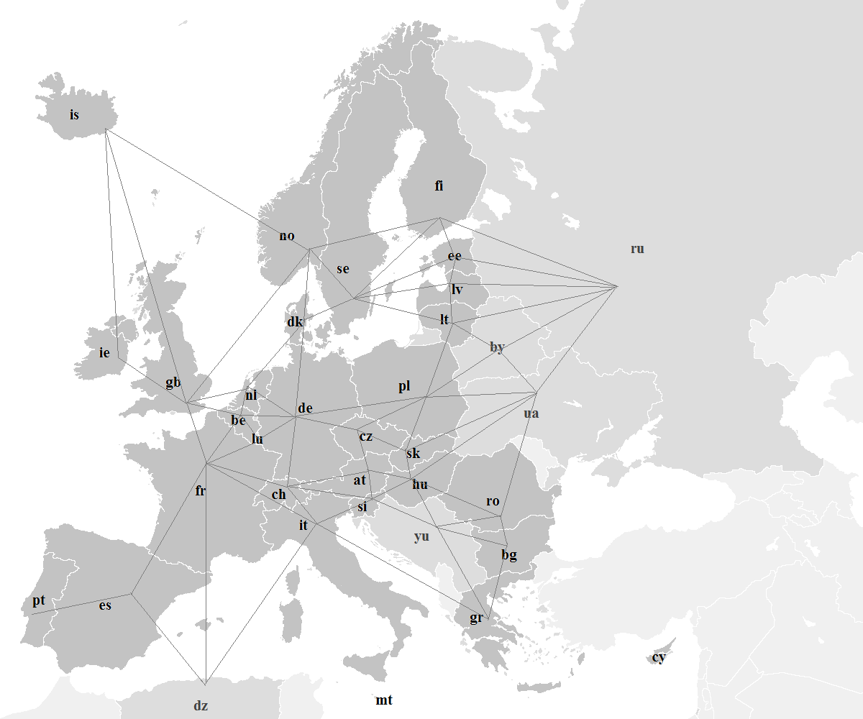All model countries are marked dark grey, whereas the exogenous countries are lighter grey. All other countries are included in row (rest of the world).

3.5.3.1 Electricity transmission capacity
Data from ENTSO-E has been used for transmission capacities between the model countries, supplemented by NORDEL (2008) for the Nordic countries. ENTSO-E provides a matrix of “Indicative values for net transfer capacities (NTC) in Europe”. It is difficult to estimate feasible transmission capacities in an electricity network, partly because all networks have weak parts that restrain feasible capacity and partly due to loop flow. ENTSO-E provides a “maximum import/export number (in MW) for some of the countries, which is much lower than reported nominal capacities between countries. This difference reflects the capacity constraints. Based on the available data from ENTSO-E for 2009 and the sources used in 2000-version of LIBEMOD (see Aune et al. 2008), it is assumed that for all alternating current (AC) transmission lines the feasible capacity is set to 50 % of the nominal capacity, whereas for direct current (DC) cables it is assumed that the feasible capacity is equal to the nominal capacity. Sea cables are typically DC.

3.5.3.2 Costs of new transmission lines
The costs of constructing new transmission lines and sea cables (used in the long-run version of the model) are based on Statnett (2006, 2008 & 2010), DENA (2011) and costs from the BritNed project (2012). For transmission lines data from projects in Norway (Statnett 2006 and 2010), and Germany (DENA 2011) have been used. These sources range between 250 and 550 €/MW per kilometre for variable costs, whereas fixed costs are around 0.02 M€/MW. In the model 500 €/MW for variable costs and 0.02 M€/MW for fixed costs has been assumed.
Statnett (2008, 2011) has cost data for sea cables from the Skagerak 4 project and the NordLink/NorGer projects. Total costs for the sea cable between the UK and the Netherlands that was finalised in 2011 is available from BritNed (2012). The above mentioned sources give a range for variable costs between 1100 and 1600 €/MW per kilometre, and fixed costs between 0.16 and 0.18 M€/MW. In the model 1500 €/MW per kilometre is used for variable costs and 0.2 M€/MW for fixed costs. These costs are combined with the distances onshore and offshore between neighbouring model countries.

3.5.3.3 Costs of operating international electricity transmission
Transmission lines are assumed to have a loss factor of 2 %, while the loss factor for sea cables is 3 %. This is in line with Amundsen and Tjøtta (1997), which for most transmission lines use a loss factor of 2 %. Data on investment costs from Statnett (2006, 2008 & 2010) has been used to find the operating and maintenance costs for transmission of electricity. The O&M costs are assumed to consist of a fixed and a variable element. For onshore cables the total O&M cost is 1.5 % of the total onshore investment costs, whereas for sea cables it is 5 % of the capital costs.

3.5.3.4 Costs of domestic transportation and distribution of electricity
Estimates for the costs of national transport and distribution are mainly taken from the Household Energy Price Index, which covers EU 15 (E-Control/VaasaETT, 2012). For the remaining model countries, data from the national reporting for the 2010 Status Review on the Liberalisation and Implementation of the Regulatory Framework (ERGEG 2010) has been used. Both publications provide a breakdown of domestic consumers’ electricity bills including distribution costs for 2009. For the industry sector data from Eurostat for EU27 and Norway (Eurostat 2010) was used.
Table 12 Transmission costs for households and industry (in €/toe)
Country | Household | Industry |  | Country | Household | Industry
at | 54.68 | 19.20 |  | ie | 62.41 | 34.70
be | 56.00 | 24.30 |  | is | 27.98 | 27.98
bg | 25.10 | 13.30 |  | it | 44.20 | 21.50
ch | 54.68 | 27.98 |  | lt | 32.96 | 41.50
cy | 42.37 | 27.99 |  | lu | 74.32 | 25.10
cz | 42.22 | 32.20 |  | lv | 41.46 | 31.30
de | 56.10 | 24.50 |  | mt | 32.24 | 22.00
dk | 68.50 | 39.00 |  | nl | 53.43 | 27.98
ee | 37.10 | 26.80 |  | no | 29.40 | 13.67
es | 41.40 | 32.00 |  | pl | 40.63 | 28.00
fi | 32.61 | 16.80 |  | pt | 51.40 | 23.40
fr | 37.35 | 27.98 |  | ro | 49.11 | 31.20
gb | 28.19 | 22.40 |  | se | 31.12 | 21.20
gr | 37.68 | 24.50 |  | si | 49.97 | 20.00
hu | 41.09 | 28.50 |  | sk | 51.10 | 52.00

IEA has data for domestic losses in 2009. In the model it is assumed that the transport losses associated with the industry sector are 2 % and the residual loss is allocated to the household and service sector.

We have created a full set of prices, including hypothetical prices for sectors with zero consumption of an energy good, to avoid problems when solving the model. Generally, prices from other sectors within each country have been used where available.
According to the IEA, the cost data has been collected from published customs statistics, but it is not specified further where the coal is delivered at this price.
The distribution cost is the cost of getting the product from the central node to the consumers. This cost varies between consumer groups and is typically higher for households than for industry.
http://e85bioethanol.com/2010/02/15/210-ft-az-e85/ provides prices for the majority of the model countries as of February 2010.
Not all of the reports have annual prices for 2009, so in some cases prices for 2008 have been used (the country reports that have time series give the impression that the price of pellets did not fluctuate very much between 2008 and 2009).
It is assumed that there are no taxes for biomass, except VAT for household customers.
Found on Gazprom’s website: http://eng.gazpromquestions.ru/?id=4#c326
These original elasticities for coal, gas and oil were based on three sources; the SEEM model (Brubakk et al., 1995), the E3EM model (Barker, 1998) and Franzen and Sterner (1995).
Eurostat, National Accounts by 21 branches - aggregates at current prices [nama_nace21_c], extracted on 17.12.2012.
Eurostat, Final consumption expenditure [indic_na], extracted on 13.12.2012.
The model can be run with Russia as an exogenous or endogenous country. When Russia is endogenous it has three regions, see chapter 3.7.
Finnish data source: http://wwwvms.vyh.fi/syke/tietoj/hbvmallit/porvoo18/reservoirs/FINNISHRESERVOIRCONTENT19782001.DAT
http://www.espon.eu/export/sites/default/Documents/Publications/MapsOfTheMonth/MapJanuary2011/PV-Potential.pdf
Data taken from: http://data.worldbank.org/indicator/AG.LND.AGRI.ZS
http://data.un.org/Data.aspx?d=EDATA&f=cmID%3aEC
For the thermal technologies a 70 % load factor has been assumed.
IEA ETSAP and IRENA provide intervals for costs, so for the existing technologies the higher end of the interval has been used, whereas for new plants the costs are assumed to be towards the lower end.
There is still considerable uncertainty surrounding the costs for CCS plants and few studies on retrofitting. It does not appear reasonable that is it cheaper to run an older coal power plant that has been retrofitted, than a new greenfield CCS plant.
Ramping load gradients are linked to the time needed to adjust the production level. For a detailed discussion see Schröder et al. (2013).
See for instance Kumar et al. (2011) for a discussion on start-up modeling.
These costs are also used by Abrell (2008).
Schröder et al. (2013) includes an overview of some additional sources for the three different types of start-ups.
The default is that investment in new nuclear power capacity is not allowed.
All costs are in 2009 Euro. When converting we have used Eurostat HCPI for inflation and exchange rates for 2009 taken from IEA Energy Prices and Taxes 2011.
There have been reports of the two EPRs currently under construction in France and Finland running over time and over budget estimate (“New nuclear power in Europe – will Finland show the way”, European Energy Review 10 January 2013). This means that we might be underestimating the costs by using a low estimate. However, because these reactors are first of a kind, it is reasonable to assume that costs will fall for future reactors.
http://www.irena.org/menu/index.aspx?mnu=Subcat&PriMenuID=36&CatID=141&SubcatID=283
IEA ETSAP Technology Brief E05, May 2010.
IEA ETSAP Technology Brief E12, May 2010.
The data from Mott MacDonald are for “nth of a kind plant” in their medium scenario.
The data from Schröder et al. includes decommissioning and waste disposal.
http://www.globalccsinstitute.com/understanding-ccs
The ZEP report compares several studies on the costs of CCS greenfield power plants. Compared to the other studies, ZEPs costs are at the lower end of the scale. This is partly due to some of the estimates being older, and probably also to the difference in type of power plants. Because the technology is still new and untested in full-scale plants it is to be expected that the estimates differ.
The IEA report Power Generation from Coal (2011) supports our coal plant choice by describing IGCC as “well placed to embrace CO₂-capture” and that the cost of CCS with this type of power plant is generally expected to be lower than for pulverised coal systems.
An alternative to pipeline transportation of the CO₂ is using ship. Transportation costs with ship are less dependent on distance and on the scale of the transport. However, to transport CO₂ by ship one has to factor in the costs of liquefaction.
It is assumed that the 20 Mtpa pipeline can serve a cluster of CO₂ sources and that it has double feeders from the source to the pipeline and double distribution pipelines.
According to the Special Eurobarometer (European Commission, 2011), six out of ten people in Europe expressed concerned when asked how they would feel about a deep underground CO₂ storage site within 5 km of their home. For an overview of studies looking at public perception and acceptance of CO₂ storage see IPCC (2005).
None of the above estimates include costs for monitoring the storage sites. IPCC (2007) estimates it to lie between 0.05 and 0.09 €/tCO₂.
In the literature there is also reference to so-called CCS-Ready plants (CCSR). The Global CCS Institute, IEA and the Carbon Sequestration Leadership Forum (CSLF) provides the following definition: “A CCS Ready facility is a large-scale industrial or power source of CO₂ which could and is intended to be retrofitted with CCS technology when the necessary regulatory and economic drivers are in place. The aim of building new facilities or modifying existing facilities to be CCS Ready is to reduce the risk of carbon emission lock-in or of being unable to fully utilise the facilities in the future without CCS (stranded assets). CCS Ready is not a CO₂ mitigation option, but a way to facilitate CO₂ mitigation in the future. CCSR ceases to be applicable in jurisdictions where the necessary drivers are already in place, or once they come in place”. Source: http://www.globalccsinstitute.com/insights/authors/christophershort/2010/11/03/definition-ccs-ready. We have decided not to model this category of plants due to the complexity of the definition of CCS-ready, and therefor only operate with greenfield plants of regular power plants that are being retrofitted.
The export price is based on Free Alongside Ship (FAS) values. This is the price of the coal delivered at the side of the ship in the port of export.
According to Hoefnagels et al. (2011), the majority of wood pellets transport within Europe is done by truck.
ENTSOG provides a map with transmission capacities for Europe and the surrounding countries for natural gas and LNG. http://www.entsog.eu/maps/transmission-capacity-map
IEA ETSAP Technology Brief P03 (2011).
All reports were found through: http://www.energy-regulators.eu/portal/page/portal/EER_HOME/EER_PUBLICATIONS/ NATIONAL_REPORTS/National%20Reporting%202010 (accessed on 25.01.2012)
We have used ENTSO-E’s online statistical database https://www.entsoe.eu/data/data-portal/, supplemented by ENTSO-E Statistical Yearbook 2010.
For some countries the reported trade from ENTSO-E is not identical to that given by the IEA Extended Energy Balances.
These two organisations merged in 2009 so ENTSO-E does not provide a complete dataset for Europe until 2010 onwards.
http://www.statnett.no/Documents/Prosjekter/Skagerrak%204/Dokumentliste/Melding/Melding_SK4.pdf, http://www.statnett.no/Documents/Prosjekter/NORD.LINK,%20kabel%20til%20Tyskland/Dokumentliste/Konsesjonssøknad/22.10.2010_Samordnet%20konsesjonssøknad%20NorGer%20og%20NORD.LINK%20sendt%20NVE.pdf
NordLink and NorGer are proposed transmission cables between Norway to Germany.
http://www.statnett.no/Documents/Prosjekter/Skagerrak%204/Dokumentliste/Melding/Melding_SK4.pdf, http://www.statnett.no/Documents/Prosjekter/NORD.LINK,%20kabel%20til%20Tyskland/Dokumentliste/Konsesjonssøknad/22.10.2010_Samordnet%20konsesjonssøknad%20NorGer%20og%20NORD.LINK%20sendt%20NVE.pdf

